# PROJECT REPORT

In this project, four graphs have been plotted using four different datasets in d3.js. Each graph and its respective attributes are detailed below.

1. Multi Line graph
2. Grouped Bar graph
3. Pie Chart
4. Scattered Plot

## Description:

### Multi Line graph

For this multi-line graph, Democratics Funds dataset is used which gives details about the expected amount of fund vs actual amount of funds raised. This dataset contains three attributes, Democratic Representative name, Expected fund to be raised and Actual fund amount raised for elections. X-axis takes all the representative names and Y axis takes fund amount values. Y axis is scaled so that it can represent other two attributes against fund raiser.

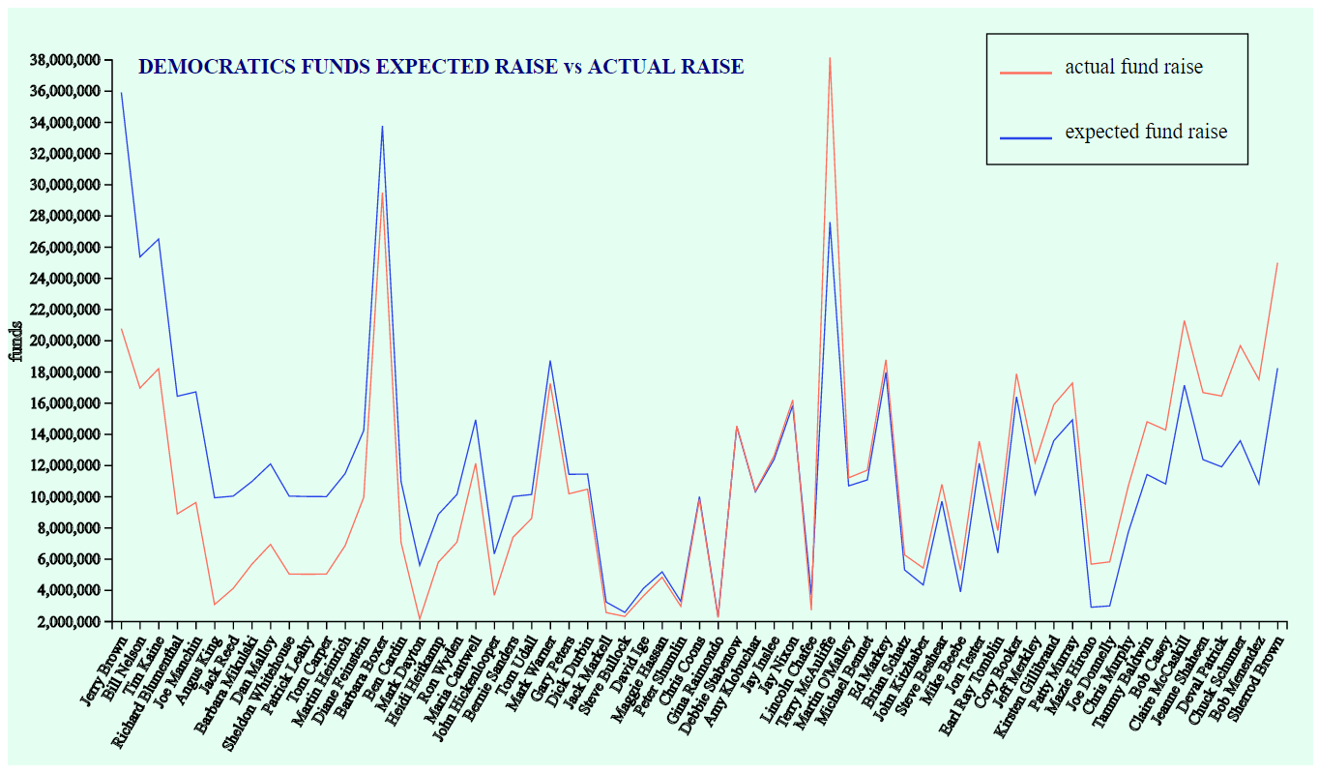

### Grouped Bar graph

Below bar graph represents dataset taken from Movie database which signifies movie rating on Fandango and the user vote count for each rated movie. Three data attributes Movie Name, IMDB rating and IMDB User vote count are considered for representation. X-axis takes Movie Name attribute, Left Y-axis takes IMDB rating (green bars) and Right Y-axis takes IMDB user vote count(red bars). Both the Y axis are scaled to accommodate the given range of values in the dataset.

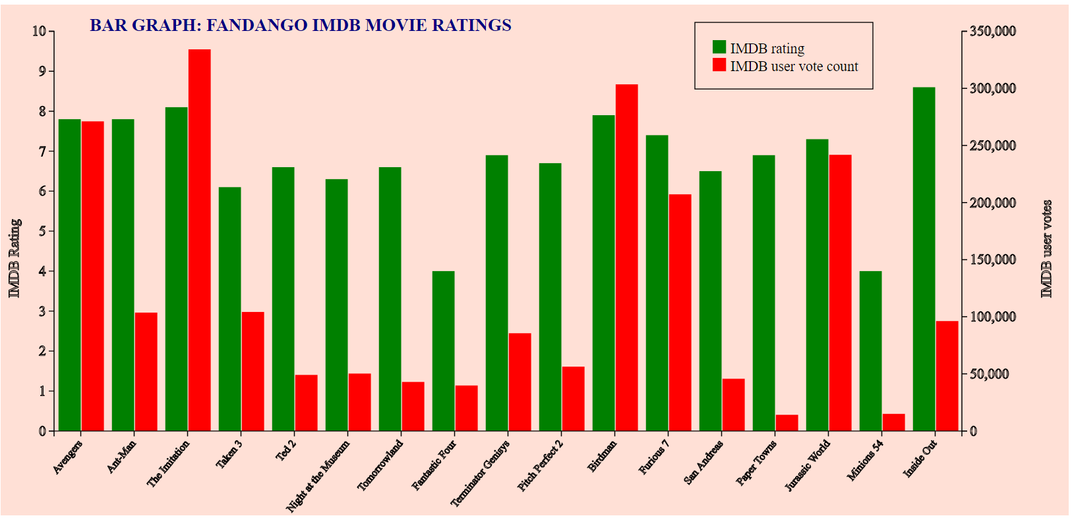

### Pie Chart

This Pie or Circular chart depicts four data attributes taken from Crime dataset containing City, Violence crime, Property Crime, Year, Murder, Robbery etc., as its attributes. Left chart denotes Property Crime occurred in five cities with outer circle for year 2013 and inner circle for 2014. Each value on the arc denotes the count of crime occurred in each city. Right pie chart denotes Violence crime like the left chart.

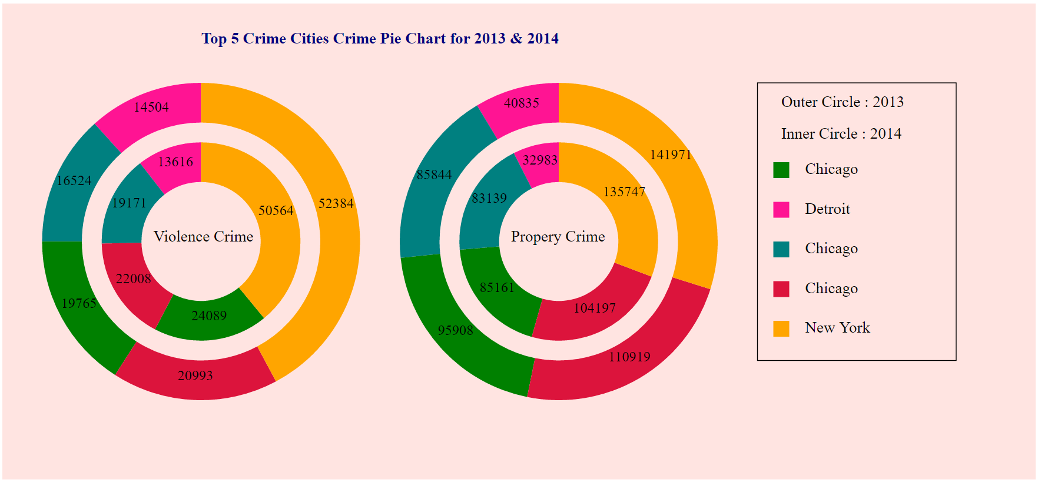

### Scattered Plot

Below Scatter Plot graph depicts share of audience watching FIFA , share of population of FIFA countries and their GDP Share. This dataset contains Country, Population Share values, TV Audience share value and GDP weighted share attributes. Below graph is plotted by considering four data attributes. Scale on Y axis is taken in such a way that, three attributes other than Country can be plotted across each Country on X-axis. Each color on the graph represents one attribute.

